**Project Design Phase-II**

**Data Flow Diagram & User Stories**

|  |  |
| --- | --- |
| Date |  |
| Team ID | PNT2025TMID09657 |
| Project Name | Rentease-HOUSE RENT APP USING MERN |
| Maximum Marks | 4 Marks |

**Data Flow Diagrams:**

A Data Flow Diagram (DFD) illustrates how data moves through a system. For a house rental application built with the MERN stack, it helps visualize the flow of information between users (tenants, owners, admins), processes, and data storage.

**External Entities**

These are the users or systems that interact with the house rental application.

* **Tenant:** A user looking to rent a property.
* **Owner:** A user who lists properties for rent.
* **Admin:** A user with administrative privileges to manage the application and its users.

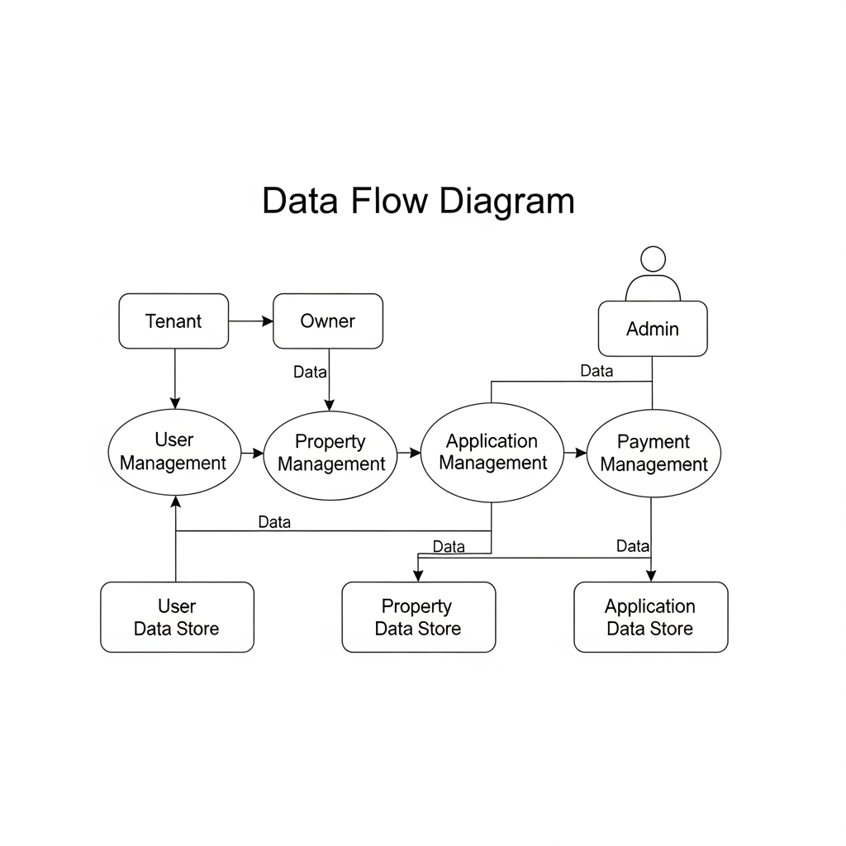

**User Stories :**

| **User Type** | **Functional Requirement (Epic)** | **User Story Number** | **User Story / Task** | **Acceptance criteria** | **Priority** | **Release** |
| --- | --- | --- | --- | --- | --- | --- |
| Customer (Mobile user) | Registration | USN-1 | As a user, I can register for the application by entering my email, password, and confirming my password. | I can access my account / dashboard | High | Sprint-1 |
| Customer (Web user) | dashboard | USN-2 | As a user, I will receive confirmation email once I have registered for the application | I can receive confirmation email & click confirm | High | Sprint-1 |
| Customer (mac user) | login | USN-3 | As a user, I can register for the application through Facebook | I can register & access the dashboard with Facebook Login | Low | Sprint-2 |
| Administrator |  | USN-4 | As a user, I can register for the application through Gmail | Can access account with email | Medium | Sprint-1 |
| Customer Care Executive | Login | USN-5 | As a user, I can log into the application by entering email & password | East to see dashboard activities | High | Sprint-1 |
| - | - | - | - | - | - | - |
| - | - | - | - | - | - | - |
| - | - | - | - | - | - | - |
| - | - | - | - | - | - | - |
| - | - | - | - | - | - | - |
| - | - | - | - | - | - | - |
| - | - | - | - | - | - | - |